✦ V2 ✦

Build a Better Blog Writer Agent

Improved Prompting Edition — Vibe Coding Guide for Non-Tech Students

5 Prompts | No Code | gpt-4o-mini

Tool: Antigravity (Google AI Coding IDE) | AI PM Cohort · Ashu Mishra

What's Improved — And Why It Matters

Before you start building, read this section carefully. Understanding WHY this version is better is more valuable than the code itself. This is what separates engineers who understand systems from people who just copy-paste.
Previous agent prompt : https://github.com/ashumishra2104/Langchain_langraph_langsmith-Theory-Tutorials-/tree/main/Blog%20Agent/Basic%20Agent

Area | Basic Version (V1) | Improved Version (V2) | Why This Makes It Better
Task / Section model | Just a plain title string — the AI decides the rest | Rich Task object: goal, 3–5 bullets, target word count, section_type | Forces the planner to think like an editor, not just name sections. Each worker gets a precise brief.
Plan model | No plan object — sections were just a flat list of strings | Plan object: blog_title, audience, tone + list of Task objects | Every worker now knows who they are writing for and in what voice — output quality jumps.
Orchestrator system prompt | Short generic prompt: 'give me 3 section titles' | 50+ line engineering-grade prompt with hard requirements, ordering rules, and mandatory elements | Better instructions = better plan = better final blog. Garbage in, garbage out — this fixes the 'in'.
Worker receives | Only section title + topic | Full context: blog title, audience, tone, section type, goal, target_words, bullets | Workers no longer guess context. Each section is coherent with the whole blog.
Worker system prompt | 'Write 2–3 paragraphs per section' | Detailed quality bar: code snippets, trade-offs, edge cases, Markdown style rules, no fluff | Technical content requires technical instructions. Vague prompts produce vague output.
Model used | gpt-4o (expensive, slower) | gpt-4o-mini (cheaper, faster — but better prompts compensate) | Smart prompting lets you use a cheaper model and still get better output. Cost-effective at scale.
Output destination | Printed to terminal only | Saved as a .md file with auto-generated filename based on blog title | Production systems write to files/databases — not just print statements.
Node naming | generate_sections / write_section / compile_blog | orchestrator / worker / reducer | Industry-standard naming for multi-agent systems. Students learn real vocabulary.

The Core Insight
V1 told the AI: 'write sections.' V2 tells the AI: 'here is the goal, the audience, the tone, the word count, the bullets to cover, and the quality bar.' The architecture is the same — LangGraph, Send(), parallel workers. What changed is the quality of the instructions going in. This is the most important thing to teach your students about AI systems: the model is not the bottleneck. The prompt is.
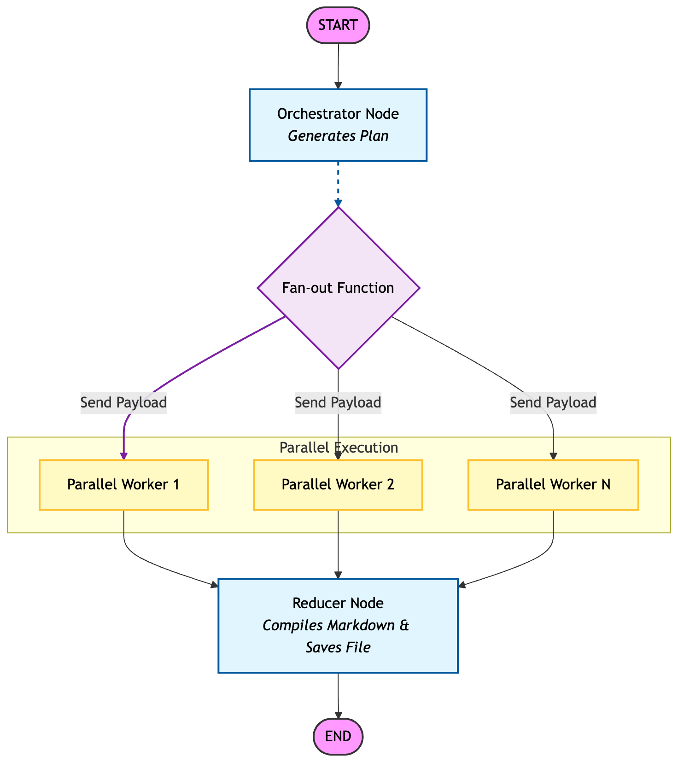

How to Use This Guide

This is a vibe coding guide. That means you describe what you want in plain English — and Antigravity writes the code. You are the architect. Antigravity is the builder. Your job is to understand what you asked for, not memorise syntax.

Step 1 | Read 'What's happening here' first. Understand the concept before you touch Antigravity.

Step 2 | Open Antigravity. Start a new Python project.

Step 3 | Copy the prompt from the dark box and paste it into Antigravity. Read what comes back.

Step 4 | Check the 'What you should see' list. If something looks wrong, describe the problem to Antigravity in plain English — do not search Stack Overflow.

Step 5 | Mark the step done mentally. Only then move to the next one.

🛠️  STEP 01 | Project Setup & Imports  Bring in every tool the agent needs — and understand why each one is there

What's happening here?
Before any agent can run, you need a project that has all its ingredients available. This step creates the Python file and installs the libraries your agent will use.
This version imports one extra thing compared to V1: Path from pathlib. This is Python's built-in tool for working with files on your computer. The improved agent doesn't just print to the terminal — it saves the blog as a real .md file. Path is what makes that happen.
The other imports are the same as V1: LangGraph (the agent framework), LangChain + OpenAI (the AI brain), Pydantic (structured data), and dotenv (safe API key loading). If you built V1, this should feel familiar — the difference is what we do with these tools.

⚡ What's improved in this step vs V1
- Added: from pathlib import Path — the agent now saves output as a real file
- Added: Literal from typing — used to enforce specific allowed values in data models

YOUR PROMPT — Copy this and paste into Antigravity

I want to build an improved Blog Writer AI Agent in Python using LangGraph and OpenAI.

Please create a new Python project for me with a file called blog_agent.py.

At the top of the file, I need these imports:
- Everything from LangGraph to build a graph-based agent (StateGraph, START, END, Send)
- LangChain with OpenAI (ChatOpenAI, SystemMessage, HumanMessage)
- Pydantic for structured data models (BaseModel, Field)
- Python's typing tools including TypedDict, List, Annotated, and Literal
- Python's pathlib module (Path) — the agent will save output to a .md file
- operator for the add reducer
- dotenv for safe API key loading

Also create a .env file where I can store my OPENAI_API_KEY safely.

Install all necessary packages. After setup, explain what each import does and why it is needed in an agent like this.

✅ What you should see after this step

- A blog_agent.py file with all imports at the top — no errors
- pathlib and Literal are included (these are new vs V1)
- A .env file ready for the API key
- An explanation from Antigravity of what each import does

📐  STEP 02 | Build the Rich Data Models  Design the Task and Plan objects — this is where V2 gets smarter than V1

What's happening here?
In V1, the planner just returned a list of section title strings — like ['Introduction', 'How It Works', 'Conclusion']. Simple. But too simple. The writer workers had nothing else to go on.
In V2, the planner returns a structured Plan object. Inside the Plan is a list of Task objects. Each Task is a detailed brief for one section. It includes: a goal (one sentence — what should the reader be able to do after reading this?), 3–5 concrete bullets to cover, a target word count, and a section_type that classifies what kind of section it is.
Think of it like the difference between handing a freelancer a post-it note vs a proper creative brief. The output quality difference is enormous. Pydantic enforces all of this at the data level — if the AI tries to return a Task without a goal, Pydantic will reject it and ask again.
The Literal type is used for section_type — it restricts the AI to only these allowed values: intro, core, examples, checklist, common_mistakes, conclusion. No free-text guessing.

⚡ What's improved in this step vs V1
- V1: sections was just a List[str] — plain title strings
- V2: Task model has goal, bullets (3–5), target_words, section_type (Literal enum)
- V2: Plan model adds blog_title, audience, tone — workers now know who they are writing for
- Literal type enforcement means the AI cannot invent new section types

YOUR PROMPT — Copy this and paste into Antigravity

Now I need to create the data models for my improved Blog Writer Agent. These models define the structure of information that flows between the AI workers.

Please create these Pydantic models:

Model 1 — Task:
This represents one section of the blog. It should have:
- An id (integer)
- A title (string — the section heading)
- A goal (string) — one sentence describing what the reader should understand or be able to do after reading this section
- A bullets field — a list of 3 to 5 strings, each one a concrete specific subpoint to cover in this section (not vague, not overlapping)
- A target_words field (integer) — the target word count for this section, between 120 and 450
- A section_type field — this must be EXACTLY one of these values using Literal type enforcement: "intro", "core", "examples", "checklist", "common_mistakes", "conclusion"

Model 2 — Plan:
This represents the full blog plan returned by the orchestrator. It should have:
- A blog_title (string)
- An audience (string) — who is this blog for
- A tone (string) — the writing style, e.g. practical, crisp, conversational
- A tasks field — a list of Task objects

Model 3 — State (TypedDict):
The shared memory for the whole agent. It needs:
- topic (string — the user's input)
- plan (Plan object)
- sections (a list of strings, using operator.add as the reducer so parallel workers can add to it simultaneously)
- final (string — the compiled blog)

After writing the models, explain: why is the Task model so much richer than just a title string? What problem does it solve?

✅ What you should see after this step

- A Task Pydantic model with goal, bullets (min 3 max 5), target_words, and section_type using Literal
- A Plan Pydantic model with blog_title, audience, tone, and tasks list
- A State TypedDict with topic, plan, sections (with operator.add), and final
- An explanation from Antigravity of why richer models produce better output

🧠  STEP 03 | Build the Orchestrator Node  The master planner — with a 50-line engineering-grade system prompt

What's happening here?
In V1, the planner had a short, generic system prompt: 'give me 3 sections.' It worked, but it produced generic outlines.
In V2, the orchestrator node has a detailed, engineering-grade system prompt that acts like a senior technical editor's style guide. It specifies hard requirements: create 5–7 sections, each must have a goal, 3–5 bullets, a word count, and the plan must include exactly one common_mistakes section. It also tells the AI what technical depth to aim for, what ordering to follow (problem → intuition → approach → implementation → trade-offs → testing → conclusion), and what kinds of bullets are NOT acceptable (vague ones like 'Explain X').
This is the most important lesson in the whole guide: prompt engineering at the system level. You are not asking the AI to 'try its best.' You are giving it a precise editorial brief and enforcing the structure through Pydantic's structured output. The AI cannot return a vague plan even if it wanted to — the schema won't allow it.
The model used here is gpt-4o-mini — cheaper and faster than gpt-4o. The improved prompt compensates for the smaller model. This is cost-effective AI engineering.

⚡ What's improved in this step vs V1
- V1: Short 2-line system prompt → generic sections
- V2: Multi-paragraph system prompt with hard requirements, ordering rules, and quality constraints
- V2: Plan returned as rich structured object (not just a list of strings)
- V2: Uses gpt-4o-mini — cheaper model, better output through better prompting
- V2: Exactly one 'common_mistakes' section enforced via prompt + Literal type

YOUR PROMPT — Copy this and paste into Antigravity

Now create the orchestrator node for my LangGraph agent. This is the master planner — it reads the blog topic and returns a full structured Plan.

Set up the LLM first: use ChatOpenAI with model gpt-4o-mini.

The orchestrator function should:
- Take the State as input
- Use llm.with_structured_output(Plan) so the AI returns a structured Plan object, not free text
- Use a detailed, engineering-quality system prompt that instructs the AI to act as a senior technical writer and developer advocate
- The system prompt must include these hard requirements:
* Create 5 to 7 sections (tasks) suitable for a technical blog
* Each section must have a goal (one sentence on what the reader learns), 3–5 concrete non-overlapping bullets, a target word count between 120 and 450, and a section_type from the allowed list
* Include EXACTLY ONE section with section_type = "common_mistakes"
* Assume the reader is a developer — use correct terminology and prefer this structure: problem → intuition → approach → implementation → trade-offs → testing/observability → conclusion
* Bullets must be actionable and testable — not vague like "Explain X" or "Discuss Y"
* The plan must include at least one of: a minimal working example, edge cases/failure modes, performance or cost considerations, security/privacy considerations, or debugging/observability tips
- The human message should pass in the topic from state
- Return the plan as {"plan": plan}

After writing the function, explain: what is the difference between a vague system prompt and an engineering-grade one? Why does it matter?

✅ What you should see after this step

- An llm variable using gpt-4o-mini (not gpt-4o)
- An orchestrator function using llm.with_structured_output(Plan)
- A long detailed system prompt with hard requirements — not just 2 lines
- The function returns {'plan': plan}
- Antigravity's explanation of why prompt quality drives output quality

⚡  STEP 04 | Build the Worker Node + Fan-Out  Parallel writers with full context — each one gets a real editorial brief

What's happening here?
In V1, each worker received just two things: the section title and the blog topic. It was like handing a writer a sticky note.
In V2, each worker receives the full context: the blog title, the audience, the tone, the topic, the section title, the section type, the goal, the target word count, and the specific bullets to cover. It is like handing a writer a proper editorial brief. The output difference is dramatic.
The worker also has a detailed system prompt telling it to be a senior technical writer — write precisely, avoid fluff, include code snippets or examples where relevant, explain trade-offs, call out edge cases, and follow Markdown style rules. This is the worker's quality bar.
The fan-out function (fanout) works exactly like V1's Send() — it launches all workers simultaneously, one per Task in the plan. The difference is that each Send() now passes the full Task object, the topic, and the whole Plan — not just a string.
The reducer node (compiler in V1) waits for all workers to finish. But in V2, it also saves the result to a real .md file on disk using Python's Path library — auto-naming the file from the blog title.

⚡ What's improved in this step vs V1
- V1 worker received: section title + topic (2 fields)
- V2 worker receives: blog title, audience, tone, topic, section title, section type, goal, target_words, bullets (full brief)
- V2 worker system prompt enforces technical quality: code snippets, trade-offs, edge cases, Markdown rules
- V2 reducer saves output to a .md file — not just prints to terminal
- Fan-out passes full Task + Plan objects via Send() — not just strings

YOUR PROMPT — Copy this and paste into Antigravity

Now add the worker node, the fan-out function, and the reducer node to my agent.

Worker node (call it "worker"):
- It receives a payload containing: a Task object, the topic string, and the full Plan object
- Extract the task, topic, and plan from the payload
- Format the task's bullets as a bullet list string
- Call llm.invoke (not with_structured_output — return raw markdown text this time)
- Use a detailed system prompt telling the AI it is a senior technical writer and developer advocate writing ONE section of a technical blog post in Markdown. The system prompt must include:
* Hard constraints: follow the Goal, cover ALL Bullets in order, stay within ±15% of the target word count, output ONLY the section content in Markdown with no extra commentary
* Technical quality bar: be precise and implementation-oriented, prefer concrete details over abstractions (APIs, data structures, protocols), when relevant include a small code snippet or example input/output or a checklist or a diagram described in text, explain trade-offs briefly (performance, cost, complexity), call out edge cases and failure modes, if you mention a best practice add the 'why'
* Markdown style: start with ## Section Title heading, use short paragraphs and bullet lists where helpful, use code fences for code, avoid fluff and marketing language
- The human message should pass all context: blog title, audience, tone, topic, section title, section type, goal, target word count, and the formatted bullets
- Return {"sections": [formatted_section_text]}

Fan-out function (call it "fanout"):
- Takes State as input
- Uses LangGraph's Send() to launch one worker per Task in state["plan"].tasks simultaneously
- Each Send() passes the task, topic, and plan to the worker

Reducer node (call it "reducer"):
- Takes State as input
- Gets the blog title from state["plan"].blog_title
- Joins all completed sections with double newlines
- Formats the final markdown as: # Blog Title followed by the joined sections
- Saves the result to a .md file — auto-generate the filename from the blog title (lowercase, spaces replaced with underscores, non-alphanumeric characters removed)
- Returns {"final": final_markdown}

After writing all three, explain: why does passing the full Task object to each worker produce better output than passing just the section title?

✅ What you should see after this step

- A worker function that unpacks task, topic, plan from payload
- A detailed multi-line system prompt in the worker — not just 'write 2–3 paragraphs'
- The human message includes blog title, audience, tone, topic, section title, section type, goal, target_words, and bullets
- A fanout function using Send() with task, topic, and plan
- A reducer function that joins sections AND saves a .md file to disk
- Antigravity's explanation of context richness vs output quality

🚀  STEP 05 | Wire the Graph & Run It  Connect all nodes, compile, run — and watch a full technical blog appear as a file

What's happening here?
This step is identical in structure to V1 — you connect the nodes with edges, compile the graph, and invoke it. The graph shape is: Start → orchestrator → fan-out → workers (parallel) → reducer → End.
What is different in V2 is what happens when you run it. In V1 you got 2–3 generic paragraphs per section printed to the terminal. In V2 you get a structured, technically rigorous blog post — with a proper title, correct Markdown headings, potentially code snippets, trade-offs, and a common_mistakes section — saved as a .md file you can open and read.
This is the payoff of everything in Steps 2–4. The graph architecture is the same. The prompt quality and data model richness are what changed the output.
Test it with the topic: 'Write a blog on Self Attention' (the same topic from the original notebook). Then compare the output to what V1 would have produced. The difference will be obvious.

⚡ What's improved in this step vs V1
- Structurally identical to V1 — same graph pattern (Start → orchestrator → fanout → worker → reducer → End)
- Output is a full .md file saved to disk — not just terminal output
- Run with 'Self Attention' topic to compare directly with V1 output

YOUR PROMPT — Copy this and paste into Antigravity

Now connect all the nodes into a LangGraph graph and run the agent.

Build the graph like this:
- Create a StateGraph using the State TypedDict
- Add three nodes: orchestrator, worker, and reducer
- Add an edge from START to orchestrator
- Add conditional edges from orchestrator using the fanout function — targeting the worker node
- Add an edge from worker to reducer
- Add an edge from reducer to END
- Compile the graph and store it as "app"

Then run the agent with this exact input topic: "Write a blog on Self Attention"
Pass it as: app.invoke({"topic": "Write a blog on Self Attention", "sections": []})

After it runs:
- Print the final blog to the terminal
- Also confirm that a .md file was saved to the project folder — print the filename

Then explain:
1. What did the orchestrator plan — how many sections, what types, what goals?
2. How many workers ran in parallel?
3. Where is the .md file saved?
4. How would you change the topic to write a blog about something else?
5. If you wanted 7 sections instead of 5, what in the code would you change?

✅ What you should see after this step

- A StateGraph with orchestrator, worker, reducer nodes connected correctly
- conditional_edges used from orchestrator with the fanout function
- The agent runs without errors
- A full blog post printed to the terminal with ## section headings
- A .md file saved to the project folder with an auto-generated filename
- Antigravity's answers to all 5 follow-up questions

🎉

You built a production-grade AI agent.

Here is what you actually learned in V2:

🗂️ | Rich data modelling — why a Task object beats a plain string
✍️ | Engineering-grade prompting — how a 50-line system prompt changes output quality
⚡ | Parallel execution with Send() — the fan-out / fan-in pattern at production scale
🎯 | Context richness — why workers need a full brief, not just a title
💾 | File output — writing to disk instead of just printing (real systems do this)
💸 | Cost-effective AI — gpt-4o-mini + better prompts beats gpt-4o + lazy prompts

Next challenge: Change the agent to write LinkedIn posts instead of blog sections. How would you update the Task model and system prompts?

